**Дрогобицький державний педагогічний університет імені Івана Франка**

**Галина Пристай**

**ПРАКТИЧНИЙ КУРС АНГЛІЙСЬКОЇ МОВИ: «THE WORLD AROUND US»**

**Навчальний посібник для самостійної роботи студентів першого (бакалаврського) рівня вищої освіти спеціальності 014 Середня освіта (Українська мова і література)**

**Дрогобич**

**2022**

**УДК 811.111(076)**

**П77**

Рекомендовано до друку вченою радою

Дрогобицького державного педагогічного університету

імені Івана Франка (протокол № від 2022 р.)

**Рецензенти:**

**Сирко І.М.,** кандидат філологічних наук, доцент, завідувач кафедри практики англійської мови Дрогобицького державного педагогічного університету імені Івана Франка;

**Савченко О.О.,** кандидат філологічних наук, доцент кафедри порівняльної педагогіки і методики викладання іноземних мов Дрогобицького державного педагогічного університету імені Івана Франка.

**Відповідальний за випуск:**

**Сосяк М. М.,** кандидат педагогічних наук, доцент, завідувач кафедри порівняльної педагогіки і методики викладання іноземних мов Дрогобицького державного педагогічного університету імені Івана Франка.

**Пристай Галина.**

**П 77** **Практичний курс англійської мови:** «Світ навколо нас»: навчальний посібник для самостійної роботи студентів першого (бакалаврського) рівня вищої освіти спеціальності 014 Середня освіта (Українська мова і література). Дрогобич: Редакційно-видавничий відділ Дрогобицького державного педагогічного університету імені Івана Франка, 2022. 54 с.

Навчальний посібник укладено відповідно до програми навчальної дисципліни «Практичний курс англійської мови» для підготовки фахівців першого (бакалаврського) рівня вищої освіти галузі знань 01 Освіта / Педагогіка, спеціальності 014 Середня освіта (Українська мова і література), освітньої програми Середня освіта (Українська мова і література, мова і література (англійська)), затвердженої вченою радою Дрогобицького педагогічного університету імені Івана Франка. До теми «Світ навколо нас» дібрано й укладено словник та комплекс практичних завдань різної складності, використано ефективні стратегії усного й писемного мовлення з метою допомогти бакалавру ефективно організувати свою самостійну роботу та здійснити самоконтроль здобутих знань.

Посібник може стати корисним для студентів, викладачів, а також усіх, хто працює самостійно над удосконаленням знань з англійської мови.

Бібліографія 11 назв.

Редакційно-видавничий відділ

дрогобицького державного педагогічного

університету імені Івана Франка, 2022

**CONTENTS / ЗМІСТ**

Передмова………………………………………………………………………. 4

# PART I. ANIMALS AND PLANTS / ЧАСТИНА І. ТВАРИНИ ТА РОСЛИНИ……………………………………………………………………………5

1. In the Wild / 1. У дикій природі ……..…………..................…………..6

2. Protecting Wildlife / 2. Охорона дикої природи…………...........…… 15

3. Pets and Farm Animals / 3. Домашні улюбленці та свійські тварини……….. 21

4. Farm Work / 4. Робота на фермі…………………....................………………... 25

5. Gardening / 5. Садівництво …………….......................…………………………30

PART II. THE PHYSICAL WORLD / ЧАСТИНА ІІ. ФІЗИЧНИЙ СВІТ.............35

6. Natural Features / 6. Природні особливості рельєфу... .................…………….36

7. Talking about rivers and the sea / 7. Говоримо про річки та море.......................40

8. Describing the universe/ 8. Описуємо всесвіт…………………….......................44

Questions for Discussion / Питання для обговорення……………………………..51

The List of Self-study Topics / Список тем для самостійного опрацювання…….52

The List of Projects / Перелік тем для проєктної роботи………………………....53

References / Список використаної літератури…………………………………….54

**ПЕРЕДМОВА**

Навчальний посібник «Практичний курс англійської мови: «The world around us» призначено для студентів для підготовки фахівців першого (бакалаврського) рівня вищої освіти галузі знань 01 Освіта / Педагогіка, спеціальності 014 Середня освіта (Українська мова і література), освітньої програми Середня освіта (Українська мова і література, мова і література (англійська)), затвердженої вченою радою Дрогобицького педагогічного університету імені Івана Франка. Посібник має чітку структуру та складається з двох частин.

Перша частина «Тварини та рослини» охоплює ряд тем. Передусім питання, що стосуються світу тварин: подано їхню загальну характеристику, описано загрози й способи захисту дикої природи, змальовано спосіб життя на фермі, догляд за домашніми улюбленцями та свійськими тваринами. До того ж, детально схарактеризовано рослинний світ й особливості садівництва як виду діяльності. Другий розділ «Фізичний світ» містить огляд природніх особливостей рельєфу, водних басейнів, а також сонячної системи.

Структура обидвох розділів чітка і зрозуміла. У словнику ви знайдете базові й найбільш вживані лексеми та словосполучення до теми. До вашої уваги запропоновано великий вибір лексичних вправ двох рівнів: B1 і B2. Крім того, методичні матеріали містять завдання для розвитку усного та писемного мовлення: наприклад, опис фотографій, відповіді на питання, читання текстів, речення на переклад. Усі вправи складено згідно з вимогами сучасних педагогічних технологій щодо розвитку іншомовної комунікативної компетентності студента, тому запропоновано ряд ідей до підготовки презентацій, проєктів, перелік проблемних ситуацій для подальшої дискусії, список тем для самостійного вивчення.

Цей посібник допоможе бакалавру ефективно організувати свою самостійну роботу з поданої теми та здійснити самоконтроль здобутих знань.

**Part I. Animals** **and plants**

**Animal VOCABULARY**

Amphibian

Animals (domestic, farm, wild, pets)

Ant

Baboon

Badger

Bat

Bear

Beaver

Bee

Bird (game bird, seabird, songbird, water bird, bird of prey)

Bream

Breed

Buffalo

Bull

Butterfly

Camel

Canary

Carnivore

Carp

Cat

Caterpillar

Chimpanzee

Cockerel

Cockroach

Cow

Crab

Crocodile (alligator)

Deer

Dog

Dolphin

Donkey

Dove

Duck

Eagle

Elephant

Elk

Extinct, extinction

Feed on

Fieldhouse

Fish

Flamingo

Fly

Fox

Frog

Giraffe

Goat

Goldfish

Goose

Gorilla

Grasshopper

Grouse

Guinea pig

Hamster

Hare

Hedgehog

Hen

Herbivore

Herd

Hippo (hippopotamus)

Horse

Insect (ants, bees, flies, locusts, mosquitoes)

Jellyfish

Jerboa

Kangaroo

Ladybird

Leopard

Lion

Lizard

Lobster

Mammal

Marmot

Marten

Mink

Mole

Monkey

Mosquito

Mouse

Musk-rat

Nutria

Octopus

Owl

Panther

Parrot

Partridge

Peacock

Penguin

Perch

Pig

Pigeon

Pike

Pike perch

Polar bear

Pony

Predator

Prey

Rabbit

Rat

Reptile (Snakes, crocodiles, tortoises)

Rhinoceros

Roe

Salmon

Scorpion

Sea Lion

Seagull

Sea-horse

Seal

Shark

Sheep

Silver-black fox

Snake

Sparrow

Species

Spider

Squirrel

Starfish

Swallow

Swan

Tiger

Titmouse

Tortoise

Trout

Turtle

Walrus

Wasp

Whale

Wild pig

Wolf

Wren

Zebra

**1. In the Wild**

**Work in pairs**

**Exercise 1.**

1. ***Decide which animal from the vocabulary list lives***

a) on land;

b) in water;

c) in the air.

1. ***Decide which animal from the vocabulary list is***

a) carnivore;

b) herbivore.

1. ***Match the animals from the vocabulary list with the correct category:***

a) insects;

b) fish;

c) birds;

d) mammals;

e) reptiles;

f) amphibians;

g) farm animals;

h) wild animals;

i) pets;

j) animals not native to Ukraine;

k) bird of prey.

**Work on your own**

**Exercise 2.**

1. ***Read the definitions and match the following creatures with the categories below.***

***crocodile frog shark tiger lobster bee ostrich***

1. a large *mammal* of the cat family that has orange fur with black stripes and lives in parts of Asia;
2. a large sea *fish* with very sharp teeth and a pointed fin on its back;
3. a big *reptile* which has a long tail, hard skin and very big jaws;
4. the largest flightless *bird* that has a long neck and long legs and can run very fast*.* It lives in Africa.
5. a black and yellow flying *insect* that can sting;
6. a *marine creature* which has a hard shell, its body is divided into sections. It has eight legs and two large claws;
7. a small animal with smooth skin, that lives both on land and in water (= is an *amphibian*).
8. ***Give the definitions of the following animals:***

Polar bear, caterpillar, deer, dolphin, owl, ladybird.

**Exercise 3.**

***Answer the questions.***

1. Which of these is not a wild animal? *Lion elephant goat rhinoceros*
2. Which of these is not a domestic animal? *Cow fox sheep pig*
3. Which of these is not usually kept as a pet? *Dog cat rabbit camel*
4. Which of these is not carnivorous? *Lion panda bear crocodile*
5. Which of these is not a predator? *Tiger gorilla leopard eagle*
6. Which of these is not an endangered species? *Penguin dolphin whale panda*

**Exercise 4.**

***Match the animals with the verbs and expressions:***

|  |  |
| --- | --- |
| 1. Birds | a. hunt in a pack, howl at night |
| 2. Dogs | b. make honey, buzz, sting |
| 3. Cats | c. roar |
| 4. Spiders | d. hiss, slither along the ground |
| 5. Wolves | e. bark, wag their tails |
| 6. Bears | f. build nests, lay eggs |
| 7. Lions | g. make webs to catch flies |

**Exercise 5.**

***Find out the difference between the following animals. Prepare an educational PPT.***

* Reptiles And Amphibians
* Frog and toad
* Alligator and crocodile
* Turtle and tortoise
* Pigeon and dove
* Dolphins and Porpoises
* Hares and Rabbits
* Butterflies and Moths
* Possums and Opossums
* Donkeys and Mules
* Leopards and Cheetahs
* Seals and Sea Lions
* Wasps and Bees

**Work in pairs**

**Exercise 6.**

***Match the words with their definitions. What category do these words belong to?***

|  |  |  |
| --- | --- | --- |
| 1. | antler | a. either of the organs on the sides of the head that you hear with |
| 2. | beak | b.one of the two horns that grow on the head of male deer |
| 3. | coat | c. you see with it |
| 4. | ear | d. a soft light part which is covering a bird’s body |
| 5. | eye | e. the hard pointed or curved outer part of a bird’s mouth |
| 6. | feather | f. the lowest part of the leg, below the ankle, on which a person or an animal stands |
| 7. | fin | g. the fur, hair or wool that covers an animal’s body |
| 8. | foot/feet | h. the area inside the head behind this opening |
| 9. | fur | i. a thin flat part that sticks out from the body of a fish, used for swimming and keeping balance |
| 10. | hoof/hooves | j. the foot of an animal that has claws or nails |
| 11. | leg | k. the soft thick mass of hair that grows on the body of some animals |
| 12. | mane | l. the hard part of the foot of some animals, for example horses |
| 13. | mouth | m. the part that sticks out at the back of the body of a bird, an animal or a fish, which the animal can move |
| 14. | paw | n. stiff hairs which grow on both sides of the mouth of a cat, mouse, etc. |
| 15. | scales | o. the long hair on the neck of a horse or a lion |
| 16. | shell | p. the hard outer part of eggs, nuts, some seeds, and some animals |
| 17. | tail | q. these body parts a bird, insect or bat uses for flying |
| 18. | tooth/teeth | r. any of the hard white structures in the mouth used for biting food |
| 19. | wings | s. any of the thin plates of hard material that cover the skin of many fish and reptiles |
| 20. | whiskers | t. one of the long parts that connect the feet to the rest of the body |

**Exercise 7.**

***Find the connection between each creature on the left and a word on the right***

e.g. Tigers have stripes.

*Tigers Snakes Bees Leopards beak stripes trunk spots*

*Elephants Goats Eagles Bears* *sting horns fur poisonous*

**Exercise 8.**

***Look at the photos below and describe the animals.***

***e.g.*** This is a horse. It has a coat, mane and hooves.

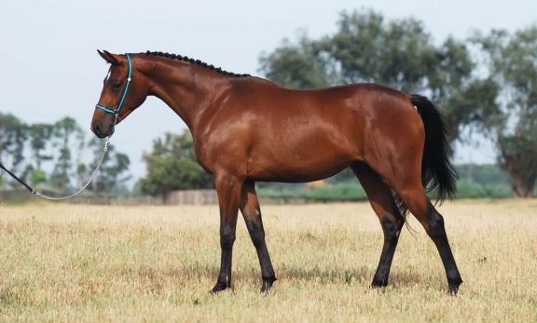

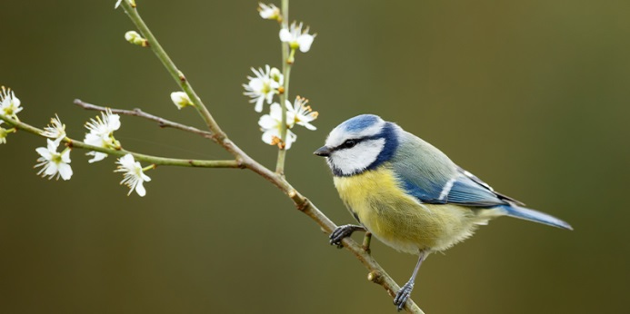 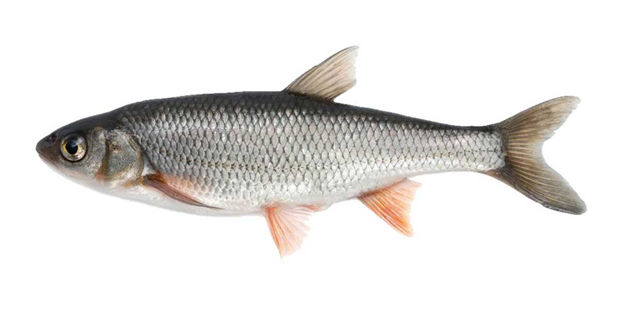

Picture1 Picture 2 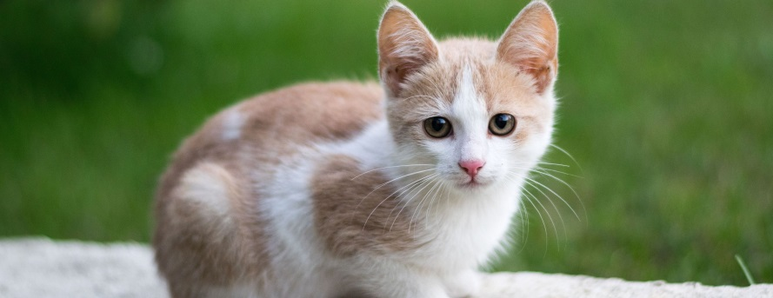 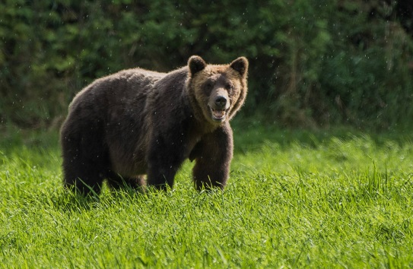

Picture 3 Picture 4

**Exercise 9.**

***Match the words (1 -7) with the animals (a-g) to make animal groups:***

|  |  |
| --- | --- |
| 1. a herd of | a. fish |
| 1. a pack of | b. whales |
| 1. a swarm of | c. wolves |
| 1. a shoal of | d. birds or sheep |
| 1. a flock of | e. cattle |
| 1. a school of | f. lions |
| 1. a pride of | g. bees |

**Exercise 10.**

1. ***Match the following proverbs and sayings 1 – 4 with their meanings a – d. Find the Ukrainian equivalents.***

1. «You can’t teach an old dog new tricks».

2. «You can lead a horse to water but you can’t make it drink».

3. «Don’t count your chickens before they hatch».

4. «The early bird catches the worm».

a) It may not happen. Don’t be too sure.

b) An old person will never change the way he or she does the things.

c) You can’t force somebody to do something they don’t want to.

d) The person who gets there first will get what they want.

1. ***Use these words to complete the idioms below:***

***Frog bull rat fish cat***

1. Why do you think they haven’t paid us yet? I’m a bit suspicious. I smell a …!
2. It was my first time at the opera and I felt like a … out of water.
3. I’m planning a surprise party for Anna. You can invite whoever you like but make sure nobody lets the … out of the bag.
4. I’ve got a bad cold and I’ve got a terrible… in my throat so I’ll stay at home, I think. Sorry.
5. I’ve been having a few problems with my neighbour’s dog coming in the garden. I’m just going to take the … by horns and go round and speak to her.

***C. Work on your own. Search for 10 animal idioms or proverbs on the Internet. Illustrate them in the example sentences / stories of your own.***

**Reading corner.**

**Exercise 11.**

***A. Read these unusual facts about animals.***

Fact 1. There are about 2,600 different kinds of snake. About 400 are *poisonous*, but more are *harmless*. In size, they *vary* enormously: the smallest are 12 centimetres long, the biggest are up to 10 metres and weigh 250 kilos. Snakes don’t need energy from food (the sun heats their bodies), so they can *survive* for months without eating.

Fact 2. The *average lifespan* of a shark is about 25 years but some can live to be 100. They are unusual in that they have no bones in their body, and large sharks may have up to 4,000 teeth. They are very dangerous when they hunt, but only a few attack humans: more people die from bee *stings* than from shark attacks.

***B. Decide if the following is true or false.***

1. The average lifespan of a snake is 25 years.
2. Most snakes are poisonous.
3. Most sharks are harmless to humans.
4. Some snakes are longer than ten metres.
5. Snakes can be heavy as 250 kilos.
6. Sharks have bones in their body.
7. Sharks sting when they attack.

***C. Complete the words in these animal facts.***

1. The average l.... of most bees is 30 to 35 days.
2. Some snakes can s... for almost a year without food.
3. Nobody knows the a... lifespan of a snake, but in zoos they can reach 30.
4. People h... sharks for their meal and skin, but also for sport.
5. Over 100 people a year die from a bee or wasp s... .
6. Snakes can grow u.. to ten metres long.
7. The size of sharks can v... from the size of your hand to the size of a bus.

**Speaking Corner**

**Exercise 12.**

***Answer the questions:***

1. Do you like animals?
2. What is your favourite animal?
3. What animals are there in your country?
4. Do you think animals were put on this planet so we could eat them?
5. What natural animal ability or talent would you like to have?
6. What is the most useful animal in the world?
7. What animals have the best life?
8. What are the biggest differences between animals and humans?
9. If animals could speak, what do you think they would say to humans?
10. What animal do you least like?

**Exercise 13.**

***Prepare a description of one of the animal or bird. Mention its appearance, main characteristics; give detailed information about its habitat.***

**Writing Corner**

**Exercise 14.**

***Translate into English:***

1. Кожен вид тварин відіграє важливу роль у світовій екосистемі.
2. Тварини забезпечують людей їжею, ліками, будівельними матеріалами та одягом.
3. Більш того, усі тварини по-своєму унікальні та красиві.
4. Світ тварин в Україні є надзвичайно різноманітний. Він охоплює сотні видів тварин і птахів.
5. Скажімо, до хижаків належать вовк, лисиця, борсук, куниця; до копитних належать козуля, олень, дика свиня, лось; також тут мешкають бобер, тушканчик, бабак, хом'як і польова миша.
6. Характерними серед птахів є горобець, синиця, рябчик, сова і куріпка.
7. Деякі хутрові звірі (нутрія, норка, лисиця сріблясто-чорна, мускусний щур), завезені в Україну, добре акліматизувалися.
8. У річках, озерах і водосховищах водяться окунь, лящ, судак, щука та короп.
9. Тваринний світ Карпат унікальний. Тут можна зустріти оленів, бурих ведмедів, диких кішок і свиней, горностаїв і чорних білок. Світ птахів охоплює кам'яних дроздів, беркутів і чорних дятлів.

**2. Protecting Wildlife**

**Exercise 15.**

***Learn the new vocabulary about threats to wildlife in general. Analyse the new words and their definitions. Make up the example sentences of your own.***

*Habitat* – the environment of a plant or animal (natural habitat)

*Deforestation* – the act of clearing forests, removing trees

*Endangered* – a species that is at risk of becoming extinct

*Species* – a group of animals/plants that share characteristics

*Be under threat of* – might be harmed or damaged

*Reserve/sanctuary* – a protected place for plants and animals

*In the wild* – in a free and natural environment not taken care by people

*In captivity* - living in a zoo (e.g. in cages)

*In decline* – gradually decreasing in number or quantity

*Breed* (bred, bred) – 1) produce young animals; 2) keep animals in order for them to produce young or for meat to sell

*Extinct* – no longer exists

**Exercise 16.**

***A. Complete the text below with these words:***

***Endangered extinct cosmetics cruelty***

***skins zoos habitats the wild experiment***

As an animal lover, I get very upset when I hear stories about 1) … to animals. I am totally against using animals in laboratory 2)… especially if it’s just to test 3) ... . I am also strongly against keeping animals in captivity. Animals should be in 4) … where they belong, not in 5) … or circuses. Why is it that 6) … species and beautiful animals, like leopards, are hunted for their 7) … when synthetic alternatives are now available? And as we continue to cut down the rainforests, we are destroying animals’ natural 8) … and more and more of them are becoming rare. The giant panda, for example, is almost 9) … . If we’re not careful, there won’t be any animals left for our grandchildren to see!

***B. Complete each fact using the following words***

***habitat ivory poaching***

***wild extinction tusk***

Items carved out of 1) ..., the white, hard material from elephant 2) ..., have been considered valuable throughout history. Although its trade is banned internationally, it still continues.

The number of tigers living in the 3) ... has dropped from 100,000 at the start of the 20th century to less than 4,000 today due to the continuing destruction of their natural 4) ... .

The continued 5) ... (illegal hunting and capturing of animals) threatens many of them with 6) ... . In some parts of the world, it affects more animals than legal forms of hunting.

**Exercise 17.**

***A. State the differences in meanings of the notion «природа» while reading the text.***

**Man versus nature**

I love being out in the open – the *countryside*, the mountains, the sea, I can’t live without them. But when I see our «civilized» societies are doing to our *natural environment,* it makes me quite ill. Not even intelligent people seem to understand the most basic *laws of nature.* Don’t they realize we weren’t put on this earth to conquer *nature* but to live in harmony with her? If people go on destroying the *balance of nature* the way they have been doing, there won’t be any *natural surroundings* left for us to enjoy.

***B. Fill in the words and word combinations in the proper gaps.***

***Nature, natural surroundings, natural environment, countryside***

1. Why don’t you go to the Carpathians? The ... there is beautiful.

2. A lot more ought to be done to preserve our ….

3. There bizarrely shaped rocks are a freak of ….

4. The island is perfect for nature lovers and sun seekers, offering unspoilt … and plenty of sun.

5. Building a motorway link to the airport along here is going to spoil the … completely.

6. It’s our children who suffer for the crimes were committing against our … .

7. He loves being in the … .

**Exercise 18.**

***Look at the pictures (1-6) which show different endangered species. Think over the reasons why they are in danger of extinction.***

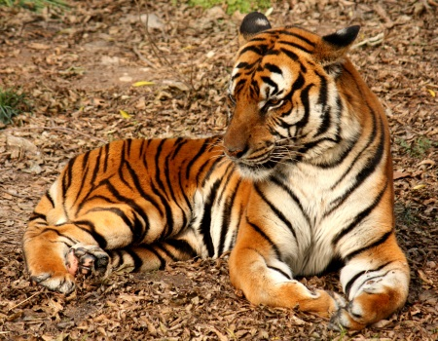 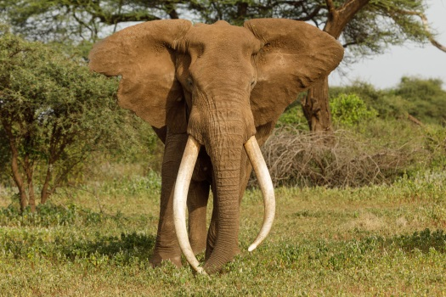

Picture 1 Picture 2

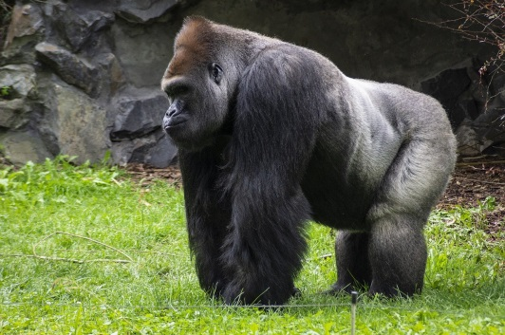 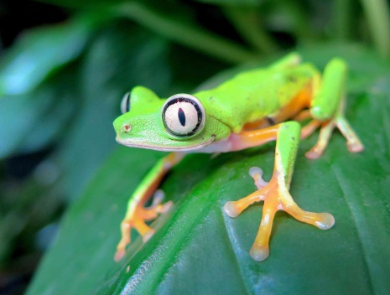

Picture 3 Picture 4

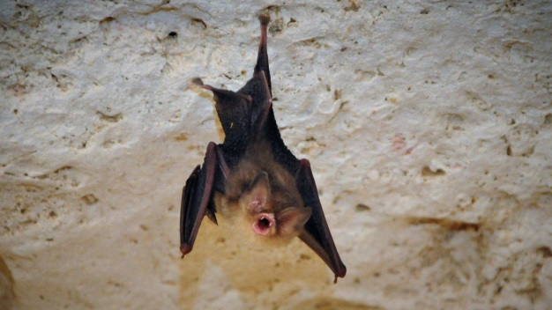 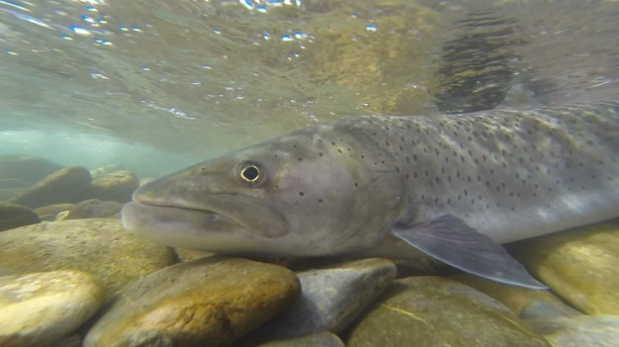

Picture 5 Picture 6

**Speaking Corner**

**Exercise 19.**

***A. Answer the questions:***

1. Are you an animal lover?
2. Have you ever been to the zoo?
3. What do you think about animals being kept in the zoos?
4. How difficult do you think it would be to run a zoo?
5. What kind of problems would you have running a zoo?
6. Do you think that zoos will survive? Why?
7. Do zoos have an important job to do? Why?
8. What is a nature reserve? What purpose does it serve for?
9. Can you name some endangered species?
10. What do you think will happen to endangered species in the next twenty years? Why?
11. Are there any laws about hunting in Ukraine?
12. What do you think of hunting? Would you eat an animal that you killed yourself?
13. Do you think it’s okay to free animals that have been in captivity all their life? Why or why not?
14. What are the threats for animals in Ukraine? What is being done about these?
15. Do you think it is acceptable to test cosmetics on animals?
16. How do you feel about the use of animals for medical research?

***B. Compare and contrast these two photos of birds: captivity and freedom, zoos, pets, protecting endangered species.***

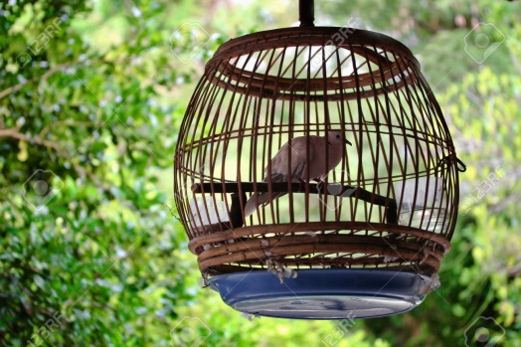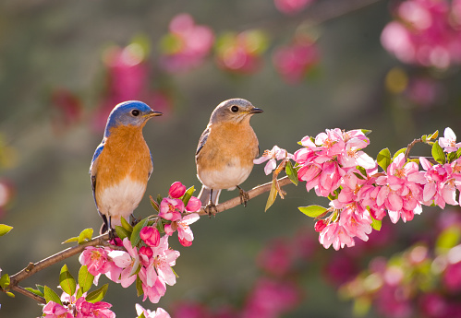

**Writing Corner**

**Exercise 20.**

***A. Translate into English:***

1. Зникаючий вид – це вид тварин, якому загрожує вимирання. Йому може загрожувати те, що його територія є під загрозою або через те, що залишилося дуже мало дорослих особин.
2. Рівень природного зникнення складав від одного до п’яти видів у рік. Теперішній рівень може сягати аж 2 000 у рік. Існує на теперішній час щонайменше 25 000 видів під загрозою зникнення.
3. Саме діяльність людини є причиною цієї проблеми. Середовища проживання тварин руйнуються забрудненням і кліматичними змінами. Наприклад, забруднення наших морів і океанів відходами є величезною проблемою для морського життя. Люди також вполювали стількох тварин, що їхня популяція не може відновитися шляхом розмноження.
4. Якщо ми не хочемо, щоб зникнення продовжувалося на тому ж рівні, ми мусимо підтримувати організації, які працюють над збереженням зникаючих видів і їхнього природнього середовища. Ми повинні перестати купувати продукти, які руйнують навколишнє середовище. Це допоможе зберегти різномаїття життя на нашій планеті.
5. Деякі люди переконані, що зоопарки мають бути закриті. Стверджується, що жорстоко тримати диких тварин у неволі. Адже чимало тварин утримується в надто малих клітках, що призводить до нудьги і агресивної поведінки. Тварини повинні полювати на здобич і жити в природному середовищі.
6. Інші люди доводять, що зоопарки мають освітню функцію, оскільки дають змогу побачити дике життя (життя диких тварин). Більш того, зоопарки є важливими охоронними осередками. Без зоопарків зникло б багато тварин. Як правило, зоопарки мають сучасні будівлі й звірі там доглянуті.

***B. During your summer holidays you worked as a volunteer in a local environmental organization. Write an article (at least 200 words) to the internet magazine for young people in which you describe your experience and express your opinion about the importance of protecting wildlife.***

**3. Pets and Farm Animals**

**Exercise 21.**

***A. Read about animal language.***

Noises made by animals can be represented lexically. This phenomenon is called *sound imitation* or *onomatopoeia*. For example, cats *mew* when they are hungry, *purr* when they are happy and *caterwaul* when they are on the roof at midnight; dogs *bark*, they also *growl* when they are hungry; lions *roar*; sheep and goats *bleat*; horses *neigh*; pigs *grunt*; cows *moo*; frogs *croak*, ducks *quack*, cocks crow ‘*cockadoodledoo*’; hens *cluck*; owls *hoot*.

***B. Complete the table with the sounds made by these animals. Consult with the dictionary.***

|  |  |
| --- | --- |
| Bears |  |
| Bees |  |
| Birds |  |
| Chicks |  |
| Crows |  |
| Grasshoppers |  |
| Hamsters |  |
| Larks |  |
| Mice |  |
| Pigs |  |
| Snakes |  |
| Whales |  |
| Wolves |  |
| HUMANS? | ;) |

***C. Some words for animal noises are used idiomatically for people. Translate the following sentences into Ukrainian.***

He *howled* in pain.

‘Get out’, he *barked.*

She *roared* with laughter.

‘I hate you’, she *hissed.*

**Exercise 22.**

***A. Match the animals on the left with their young on the right:***

|  |  |
| --- | --- |
| 1. hen | a. calf |
| 2. pig | b. duckling |
| 3. sheep | c. foal |
| 4. horse | d. kid |
| 5. cow | e. chicken |
| 6. duck | f. piglet |
| 7. goat | g. lamb |

***B. Complete the table with the names of the YOUNG animals. Consult with the dictionary.***

|  |  |
| --- | --- |
| bear |  |
| cat |  |
| deer |  |
| dog |  |
| eagle |  |
| fish |  |
| fox |  |
| frog |  |
| goat |  |
| goose |  |

***C. Match up the animals and their meat. Sometimes two answers are possible.***

|  |  |
| --- | --- |
| 1. cow | a. venison |
| 2. hen | b. lamb |
| 3. pig | c. veal |
| 4. calf | d. pork |
| 5. deer | e. ham |
| 6. sheep | f. chicken |
|  | g. bacon |
|  | h. beef |

***D. Work in pairs. Make up a description of an animal (wild or domestic), mention the place where it lives, the sound it produces, the name of its babies, whether it is carnivore or herbivore, etc. Let your partner guess what animal it is.***

e.g. It is a wild animal which lives both on land and in water. So people call it amphibian. A tadpole is the young form of it. It croaks which means it produces a deep hoarse sound, particularly at night. It is green. It has four legs but no tail. It can swim and jump. I think it is carnivore because it eats insects.

**Speaking Corner**

**Exercise 23.**

***Answer the questions:***

1. Do you keep any pets?
2. Did you have a pet when you were a child?
3. Why are pets important for kids?
4. What are the pros and cons of keeping a pet?
5. What kind of pet would you keep? Why?
6. What is a breed? What breeds can you name?
7. Which dog breed do you think is the most intelligent and which is the dumbest?
8. ‘People shouldn’t keep wild animals as pets’. Do you agree?
9. What exotic pets do some people have?
10. What unusual pet would you like to have? Why?

**Writing Corner**

**Exercise 24.**

***A. Translate into English:***

1. Домашні тварини, особливо собаки та кішки, можуть зменшити стрес, тривожність і депресію.
2. Турбота про тварину може допомогти дитині вирости більш безпечною та активною.
3. Домашні тварини також є цінним товариством для літніх людей.
4. Домашні тварини забезпечують товариство і захист, а з власниками формуються унікальні зв’язки.
5. Окрім того, що вони є джерелом любові та дружби, численні наукові дослідження доводять користь домашніх тварин для нашого здоров’я.
6. Чому домашні тварини кращі за людей? Немає нікого більш відданого, ніж тварина, про яку ви турбуєтесь.
7. Спільнота власників домашніх тварин неймовірно дружня – ви часто помітите, що люди зупиняються, щоб поговорити з вами про вашу собаку в парку. Завести домашню тварину – це чудовий спосіб познайомитися з новими людьми та швидко налагодити зв’язки, особливо якщо вам не легко розпочати розмову першим. Бути власником собаки може допомогти вам зустріти кохання свого життя!

***B. You’ve received a letter from your pen-friend in which he/she asks your advice on what pet to keep. Express your ideas by comparing advantages and disadvantages of having a particular pet.***

**4. Farm Work.**

**Exercise 25.**

***Read aloud 3 times in a row this phonetic drill:***

Shorn – corn – worn – forty

Rat – cattle – cash – fat – flat

Plough – cow – how – brown – mouth

Farmer – barley – barn – car – father

Rodent – crow – sow – show – blow

**Exercise 26.**

***A. Read the description of typical farmer’s work. Give the definitions of the verbs in italics. Ask 5 questions on the text.***

August, September and October is the busy season for any farmer. He has his hands full gathering in. The most important job is to *harvest* the crop: that is to *gather in* the vegetables and to *reap* wheat and corn. The potatoes are usually *dug* in September and *store*d in pits. All the grains must be in stacks and covered safe from rain. Besides the fruit is ready to be *pick*ed. By the way, the apples may be sold, stored or made into cider. The last two crops to harvest are mangolds and sugar beet. The mangolds are grown for the cattle, so that they have the moist fresh food during winter. The farmers have to work from morning till night. When the crops have been gathered, a farmer begins preparations for the next year’s harvest.

In addition to *plow*ing, *sow*ing and root harvesting, a farmer has a lot of work with the farm’s livestock. The cows must be milked and fed twice. Besides, he must clean the cowsheds. A farmer must look after his stables and his horses, sheep pens and sheep or rabbit hutches and rabbits. Moreover, he has to take great care of the young animals: the lambs and the calves. The poultry live in a special shed (poultry yard) and have boxes for their food and water and a place where they can lay eggs.

Warm season is an easy time for the farm animals as the cows, sheep and horses get most of the food from the pasture. But in winter they can’t *graze* so when it’s the hay-making time, a farmer should *mow* the grass with a scythe or a mowing machine. Then the grass is *rake*d with a hay-rake and *stack*ed by a stacker.

***B. Fill in the chart on activities done on a farm.***

|  |  |  |  |  |
| --- | --- | --- | --- | --- |
|  | ***spring*** | ***summer*** | ***autumn*** | ***winter*** |
| 1. The fields are planted. |  |  |  |  |
| 2. The fruit is picked. |  |  |  |  |
| 3. The crops are sprayed. |  |  |  |  |
| 4. The fields are planned. |  |  |  |  |
| 5. The corn is reaped. |  |  |  |  |
| 6. The wood is chopped. |  |  |  |  |
| 7. The crops are stored in the barns. |  |  |  |  |
| 8. The fields are plowed. |  |  |  |  |
| 9. The fields are watered. |  |  |  |  |
| 10. The fields are fertilized. |  |  |  |  |

***C. Put these events in a logical order.***

1. First, the farmers

2. Then, they

3. After that, they

4. They may have to

5. Finally, it’s time to

6. Then they have to

7. Now they can

a) harvest the crops.

b) fertilize their fields.

c) feed the animals in the winter.

d) store the crops.

e) plant the crops.

f) plow the fields.

g) spray the crops

***D. Match the verbs on the left with each noun on the right. Sometimes more than one option is possible.***

1. plow

2. harvest

3. chop

4. feed

5. pick

6. water

a) the horses

b) the soil

c) the wood

d) the crops

e) the corn

f) the grapes

g) the chickens

i) the vegetables

j) the fields

***E. Work on your own and find out the following notions:***

1. What do we call

* a place where a farmer keeps horses, cows, swine, bees, rabbits, poultry; grows flowers, vegetables, grain;
* a person who treats and takes care of animals; takes care of cattle, cows, swine, poultry, flowers; is responsible for the whole farm.

2. Make up a list of

* crops breeding
* animal husbandry

***F. Use the correct form of these verbs in the sentences below:***

***Slaughter breed graze milk***

1. Farmers have to get up early to ….. the cows.
2. If you go for a drive in the country, you’ll see sheep and cows … in the fields.
3. The bulls used in bullfights are … specially.
4. It makes me sad to think that these lovely little lambs will soon be … .

**Speaking Corner**

**Exercise 27.**

***Answer the questions:***

1. Is Ukraine an agricultural country?
2. What are the major farming branches in Ukraine?
3. What crops are farmed here?
4. What livestock is raised in our country?
5. Does farming offer a good quality of life?
6. What do you think of farming genetically modifying crops?
7. Is the farming of crops for biofuels a good or bad idea?
8. Name the challenges the farming industry faces today.
9. Would you like to be a farmer?
10. Some people believe that farming helps preserve the countryside. Do you agree?
11. Should the government encourage organic farming?
12. What do you understand by the term ‘urban farming’?

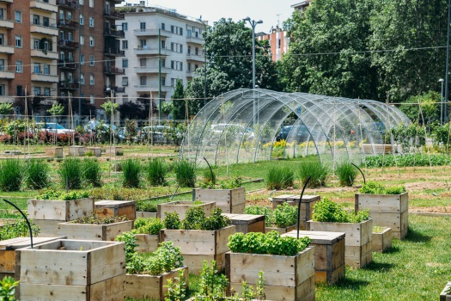

**Writing Corner**

**Exercise 28.**

***A. Translate into English:***

1. Я люблю гуляти посеред лугів.
2. Узимку поля пусті.
3. Фермери завжди повинні багато працювати.
4. Чи буде хороший врожай цього року?
5. Деколи для ґрунту необхідно багато добрив.
6. Добриво стає все більш дорожчим.
7. Чи жито росте швидко?
8. Ми заготовлятимемо сіно наступного місяця.
9. Цьогорічний врожай багатший, ніж попередній.
10. Минулого тижня вони викопали картоплю.
11. Усю пшеницю змололи, а жито обмолотили.
12. Ти вже зорав свої поля?
13. Чи вирощував він раніше помідори?
14. Цей плуг потрібно відремонтувати. Він часто несправний.
15. Він вирощує всі види зернових, окрім ячменю.
16. Вони сіяли пшеницю зранку до вечора вчора.
17. Я ще не подоїла корову. Вона пасеться на пасовищі.
18. Того спекотного літа врожаю не було (не вдався).
19. Це опудало лякає птахів.
20. Гризуни в нашій стодолі їдять зерно.

***B. Write an essay about jobs done on a farm in different seasons.***

**5. Gardening**

**Flora Vocabulary**

Acacia

Anemone

Ash

Aspen

Baobab

Beech

Birch

Blossom

Branch

Buds

Bush

Carnation

Cedar

Chestnut

Chestnut

Chrysanthemum Daffodil

Chrysanthemum

Cypress

Daffodil

Elm

Eucalyptus

Fir

Flower

Fruit

Gladiolus

Hornbeam

Hyacinth

Leaf/leaves

Lily

Maple

Oak

Orchid

Palm

Peruvian lily

Petal

Pine

Poplar

Rose

Seed

Sequoia

Stem

Sunflower

Sycamore

Thorn

Tree

Trunk

Tulip

Twig

Vegetable

Walnut

Weeds

Willow

**Exercise 29.**

***A. Match the words with the pictures***

***leaf roots thorn blossom brunch fruit trunk***

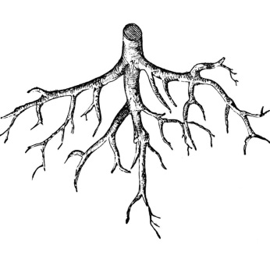 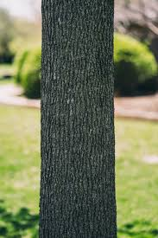 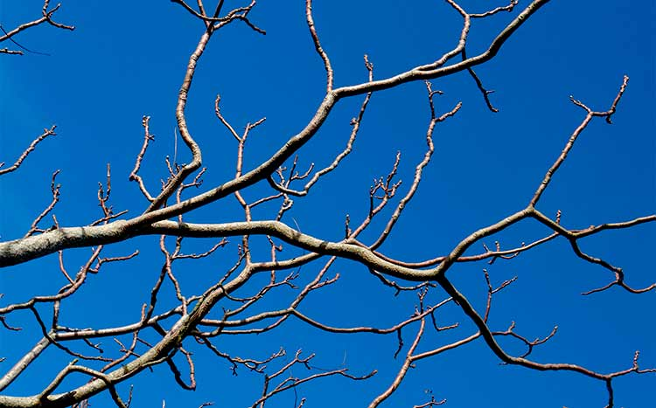Picture 1 Picture 2 Picture 3

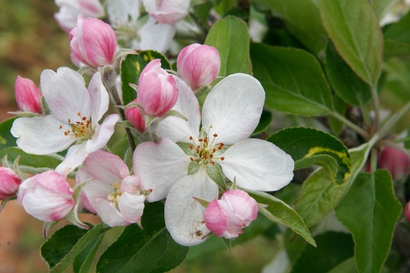 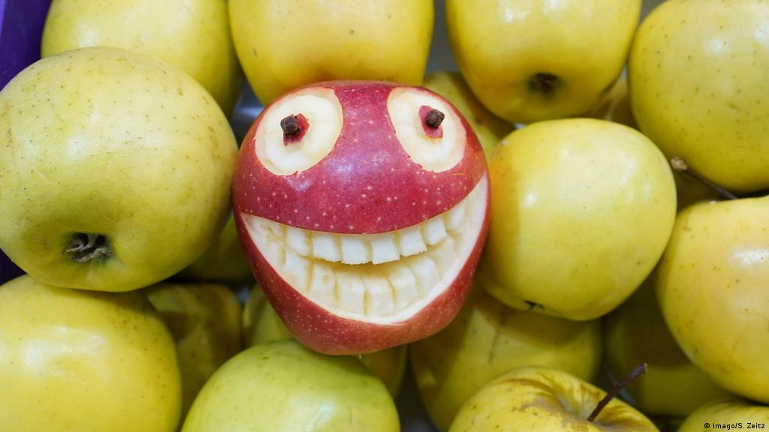

Picture 4 Picture 5

 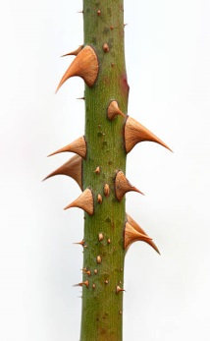

Picture 6 Picture 7

***B. Draw a flower and name its parts.***

**Exercise 34.**

***A. Classify the following words into groups, comprising the generic term (hyperonym) and the names of the species (hyponyms).***

Acacia, anemone, ash, aspen, baobab, bald eagle, bird, birch, carnation, cedar, chestnut, chicken, chimpanzee, chrysanthemum, clams, cock, coral, cow, coyote, crab, crow, cypress, daffodil, deer, dog, dolphin, dove, duck, Earth, elm; elephant, eucalyptus, fir, fish, flower, fowl, fox, giraffe, gladiolus, goat, goose, hawk, hedgehog, hen, hickory, hippopotamus, horse, hyacinth, jellyfish, Jupiter, kangaroo, koala, leopard, lily, lion, lobster, mammal, maple, Mars, Mercury, mole, monkey, mouse, Neptune, oak, octopus, orchid, ostrich, otter, ox, oyster, palm, panda, peacock, pelican, penguin, Peruvian lily, pig, pigeon, pine, planet, Pluto, poplar, raccoon, Saturn, seagull, seal, sequoia, shark, sheep, shells, shrimp, sparrow, squid, squirrel, starfish, sunflower, sycamore, swan, tree, tulip, turkey, turtle, Uranus, Venus, walnut, walrus, whale, willow.

|  |  |
| --- | --- |
| hyperonym | hyponyms |

***B. Decide***

* Whether the trees from exercise A are coniferous (evergreen) or deciduous.
* What season are the flowers for.

**Exercise 35.**

***A. Complete the sentences with the garden idioms below:***

*Cool as a cucumber*

*Rotten to the core*

*Apple of someone’s (mother’s) eye*

*Weed out sth/smb*

*Cream of the crop*

*Dirty work*

*Bed of roses*

*Beat around the bush*

*Easy as apple pie*

*Clear as mud*

*Apples and oranges*

*Have one’s ear to the ground*

1. The test we took last week and today’s test are like…. They’re completely different.

2. During the exam Giselle was … , because she knew all the answers.

3. Cindy is… . She always receives the nicest gift.

4. Andy is …. He never does his work and blames everyone for his mistakes.

5. Your excuse is … So you need to explain it to me again.

6. Learning to tie your shoes is ….Children can do it quickly.

7. Stop …, Peter, and answer the question. Are you sick or not?

8. Agnes …, hoping she would get new information about her job.

9. The students were … Their grades were outstanding.

10. I am going through my magazines to …. those I don’t need to keep.

11. When Catherine entered the classroom she could tell there had been some… … going on, because everyone started laughing.

12. Being the boss is not exactly …She has to take responsibility for everyone’s reports.

***B. Match the proverb with its meaning. Find the Ukrainian equivalents.***

|  |  |
| --- | --- |
| 1. An apple a day keeps the doctor away. | a) if you continually striving for the best, you may lose good opportunity. |
| 2. April showers bring May flowers. | b) you will stay healthy if you eat one. |
| 3. As you sow, so shall you reap. | c) if you behave well, good things will happen and vice versa. |
| 4. As is the gardener, such is the garden. | d) you share traits or resemble someone in your family. |
| 5. Green leaves and brown leaves fall from the same tree. | e) something that you do not enjoy may lead to something you do enjoy. |
| 6. An apple never falls far from the tree. | f) your work reflects your personality |

**Speaking corner**

**Exercise 36.**

A. What does the phrase ‘web of life’ mean to you? Do you believe that everything on the planet is connected? How? Do the actions of people, animals, and plants affect you? How? Does your life influence other people, animals, plants? How?

B. Compare the work on a farm a hundred years ago and now. How do you think farming will change in the future?

C. Compare and contrast these two photos of farming – organic and conventional. Discuss the production system, kinds of fertilizers, chemical pesticides, genetically modified organisms, contribution to pollution and the state of the soil.

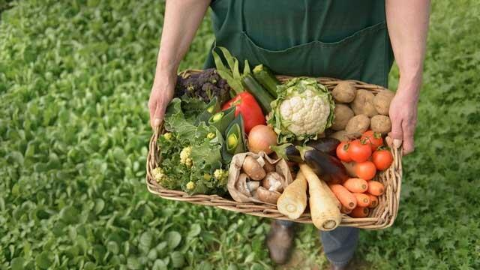 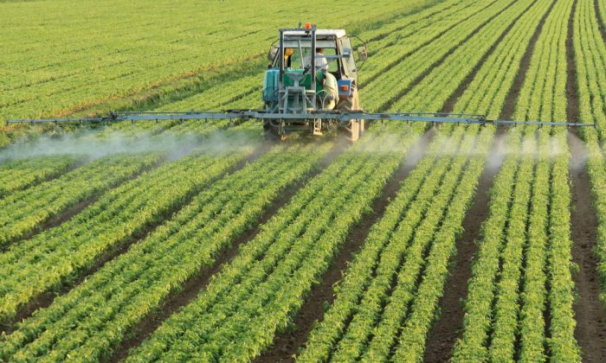

Picture 1 Picture 2

**Writing Corner**

**Exercise 37.**

***A. Translate into English:***

1. Я додала перегною, щоб удобрити грунт.
2. Коріння рослини вбирає воду, щоб її підживити
3. Усі садоводи хочуть привабити бджіл і метеликів у свої сади.
4. Вам варто лише посіяти зерно поверх ґрунту і тоді накрити його.
5. Я хочу більш незвичний сад – з дикими квітами і травою, більше схожий на луг.
6. Деякі квіти виростають з бульб, які висаджують у ґрунт.
7. Глянь! Ось величезний бур’ян, який росте якраз біля дверей. Вирви його.
8. Важливо збагатити ґрунт перегноєм перед тим, як садити рослини. Перегній робить ґрунт більш родючим.
9. Тобі варто посадити ряд кущиків, щоб зробити красивий живопліт уздовж твого саду.
10. Якщо кущі виростуть занадто високими, тобі буде потрібно трохи їх обрізати.
11. Траву потрібно покосити. Ти знайдеш газонокосарку в сараї.
12. Мені треба трохи скопати, але я не можу знайти лопату.

**PART II. THE PHYSICAL WORLD**

**VOCABULARY**

Bay

Beach

Canal

Canyon

Carnation

Cave

City

Cliff

Coast

Countryside

Gulf

Desert

Forest

Grass

Harbour

Hedges

Hill

Island

Lake

Lane

Mountain (ranges)

Ocean

Path

Plant

Pebble

Peninsular

Pond

Puddle

Rainforest

River

Reef

Road

Rock

Root

Sand

Sea

Shore

Soil

Stream

Tide

Town

Valley

Volcano

Waterfall

Wave

Wood

**6. Natural Features**

**Exercise 38.**

***A. Which words are being defined? Match the words and their definitions.***

***Island valley lake river cave waterfall***

***cliffs mountain rocks forest***

1. water that moves in a long line across the land to the sea
2. a large area thickly covered with trees
3. a body of land surrounded by water
4. a type of low land between ranges of hills or mountains
5. an area filled with water and surrounded by land
6. a place where a stream or river falls from a high place over a drop (cliff or rock)
7. a mass of rock with a very steep vertical side (at the edge of the sea or ocean)
8. the hard solid material, a large piece of stone
9. an opening (a natural void) in the side of a hill or cliff or under the ground
10. a very high hill, often with rocks near the top

***B. Give the definitions of the following:***

*Ocean –*

*Hill –*

*Lane –*

*Gulf –*

*Pond –*

*Pebble –*

*Bush –*

*Coast –*

*Stream –*

*Waterfall –*

**Exercise 39.**

**Making collocations**

***A. Match the adjectives and nouns:***

|  |  |
| --- | --- |
| 1. thick or dense | a. path |
| 2. fertile or arid | b. hill |
| 3. winding or mountain | c. land |
| 4. steep or gentle | d. shore |
| 5. sandy or rocky | e. forest |

***B. Put two of the following adjectives with the opposite meanings in front of each of the nouns:***

***Flat deep high low hilly shallow***

6. ......., ...... countryside

7. ......, ...... tide

8. ......, ...... river

***C. Now use some of the adjectives from 1-8 above to complete these sentences:***

1. At ... tide you can walk across the sand to that island.

2. Cycling into work is OK, but cycling home isn’t easy. There’s a really ... hill!

3. We should be able to get across the river here – it’s quite ... .

4. Be careful if you go swimming here. The water’s quite ... .

5. The land in this part of the country is very ... . We can grow anything here.

6. The Netherlands is incredibly ... . There are hardly any hills at all.

7. Mushrooms grow best on the floor of ..., damp forests.

8. The countryside round here is very ... so not many people use a bike.

***D. What adjectives to use to describe***

1. a view?
2. a mountain?
3. a waterfall?
4. grass?
5. an ocean?
6. a gulf?
7. a tree?
8. a valley?

**Exercise 40.**

***Which is bigger? Prepare an educational PPT using the pictures of these locations.***

1. a forest or a wood?
2. a stream or a river?
3. a lake or a sea?
4. a mountain or a hill?
5. a tree or a bush?
6. a twig or a branch?
7. a sea or an ocean?
8. a gulf or a bay?
9. a pond or a lake?
10. a road or a lane?
11. a rock or a pebble?
12. a town or a city?

**Exercise 41.**

***A. Match the words on the left with a word on the right to make the name of a famous place. Prepare an educational PPT using the pictures of these places.***

1. The Indian
2. The Dead
3. The Sahara
4. The Great Barrier
5. Grand
6. Mount
7. Niagara
8. Ayers
9. Lake
10. Loch

a) Canyon

b) Falls

c) Garda

d) Rock

e) Ocean

f) Reef

g) Ness

h) Sea

i) Everest

j) Desert

**Speaking corner**

**Exercise 42.**

***Describe the pictures (1–5). In which part of the world do you think each of the pictures could be?***

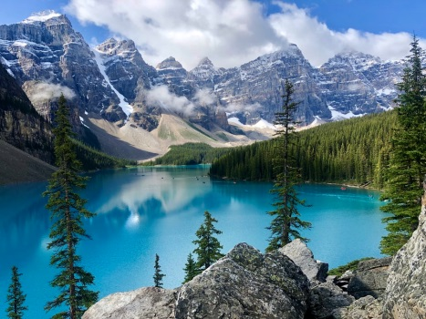 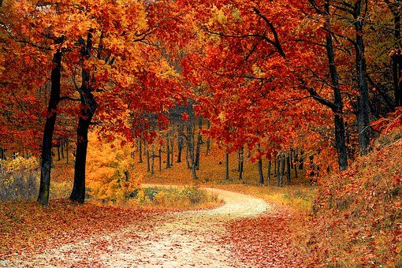

Picture 1 Picture 2

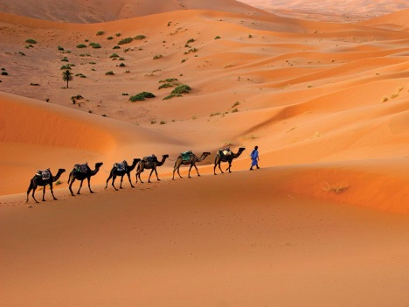 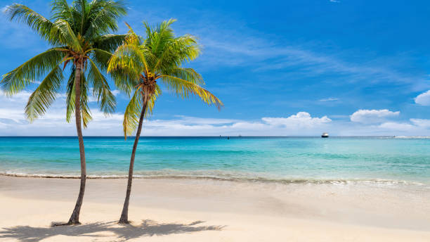

Picture 3 Picture 4

 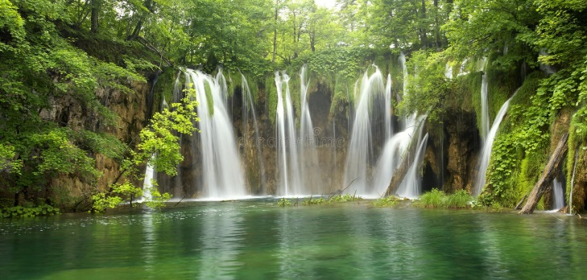

Picture 5 Picture 6

**Writing Corner**

**Exercise 43.**

***A. Translate into English:***

1. Україна омивається Чорним і Азовським морем на півдні.
2. На півночі України розташовані ліси, на заході – Карпатські гори, а в східній та центральній частинах – степові чорноземи.
3. Ми можемо насолоджуватися мальовничими схилами зелених Карпат, лісами Полтави, Чернігова і Києва, безкрайніми степами Херсона, Миколаєва та Одеси.
4. Україна – це земля лісів, озер та річок. В Україні протікає 131 річка. Найдовші з них – Дністер, Донець і Буг. Дніпро – головна річка України. Більшість річок судноплавні.
5. Україна багата на природні чудеса, такі як найбільший каньйон Європи, мальовниче високогірне озеро, місто на воді, цілинний степ тощо. Ці унікальні місця є визначними пам'ятками України.

***B. Write a leaflet advertising the natural wonders of your village, town or region.***

**7. Talking about rivers and the sea**

**Exercise 44.**

***A. Read this piece of information. Ask 4 questions on the text. Memorise the words in italics.***

Rivers *flow* to the sea. A river can be *wide* and *deep* or *narrow* and *shallow.* If it rains heavily, a river can *burst* its *banks*, which *causes floods*. If there is no rain for a long time, the river *dries up*.

The *tide* comes in (*high tide*) and goes out (*low tide*) twice a day. Boats *float* on the *surface* of the water. In bad weather, a boat can *capsize* and *sink*. People on the boat may be trapped underwater and may *drown*.

***B. Answer the questions.***

1. Do streams have a tide?
2. Is the depth of a river the same as it width?
3. Do puddles form when it rains a lot?
4. Can people float in water?
5. Can people capsize?
6. Can a pond dry up?
7. Can people swim up a waterfall?
8. Can people sit on the bank of a river?
9. Are canals deeper than seas?
10. Does water flaw in a pond?

**Word building corner**

***C. Make nouns out of these adjectives:*** *e.g. strong – strength*

*Wide –*

*Deep –*

*Long –*

*Broad –*

*High*

***D. Circle the correct word.***

1. The river Siena *floats/flows* through Paris.
2. The leaves floated on the *surface/underwater*.
3. I went sailing on the *pond/lake*.
4. The ship *capsized/drowned* in the storm.
5. I swam across the whole *depth/width* of the river.
6. There’s a little *stream/tide* at the end of our garden.
7. Sadly the dog *drowned/sank* when the ship capsized.
8. You can stand up in the river here; it’s very *narrow/shallow*.
9. Our furniture got very wet during the *floods/tides*.

***E. Complete the text with a suitable word in the correct form.***

We had some storms with very heavy rain last summer. The river which runs through the city 1)... its banks, and 2) ... serious floods. The water was quite 3)... : it was two metres in some parts, and you could see people’s possessions 4)... in the water.

We had a terrible day sailing on a 5) ... in the mountains last weekend. The wind was very strong, and suddenly our little boat 6) ... and we ended up in the water. We swam to safety, but watched the boat slowly 7) ... to the bottom. Later we discovered it was very dangerous there, and last year someone 8) ... .

**Exercise 45.**

***A. Read the text. Ask 4 questions on the text. Memorise the words in italics.***

Our local *beach* is mainly *sandy*, with a few *rocks* and *pebbles* down by the shore. There’s a *steep cliff* rising above the beach, and children often play in the *caves* there. At the end of the *bay* there’s a small *harbour*. When the weather’s bad, the *sailing boats* are protected from the waves and the *rough* sea. We often see large ships on the *horizon*.

***B. Which words are being defined?***

1. a small stone you find on a beach

2. the line between the land or the sea and the sky

3. a big piece of stone

4. an stretch of land commonly sandy or with small stones along the edge of an ocean/sea

5. a high steep area of rock next to the sea

6. a large boat often used to carry passengers

7. the land at the edge of the sea where there is a sand or rocks

8. a large hole in a cliff or under the ground

9. a place where ships or boats are tied up and protected from the sea

10. the area of land next to the sea

11. an area of the coast where the land goes in to form a curve

***C. Complete the sentences***

1. It was a nice day, so we went to the ...

2. When it’s stormy, the sea gets very....

3. A huge ... hit the boat and we capsized.

4. At one end of the beach there are rocks and pebbles, but the other end is ...

5. The harbour ... the little boats in bad weather.

6. You can’t climb the cliff, it’s too ... .

7. I could see a boat ... the horizon.

**Exercise 46.**

***Find out the difference between the following notions. Prepare an educational PPT.***

* tide’s in and tide’s out
* a shore and a coast
* inland and coastal
* a bank and a shore
* a canal and a channel
* a harbour and a bay
* a liner and a ship
* a cave and a grotto

**Speaking corner**

**Exercise 47.**

1. Are you a sea or a mountain person?
2. What adjectives would you use to describe oceans?
3. Have you ever been near the ocean? What experiences have you had in your life with oceans?
4. What are the most beautiful creatures living in the oceans?
5. How do the oceans affect the weather?
6. What’s the difference between a sea and an ocean?
7. How can we protect the world’s oceans which are in danger?
8. How is the start of a river called? How is the end of a river called?
9. Why can rivers be dangerous?
10. What is the longest river in the world?
11. What is the longest river in the UK? What is the most important one? What is the widest river in the UK?

**Writing Corner**

**Exercise 48.**

***Translate into English:***

1. Ця річка тече до моря. Вона в одних місцях широка, але дуже вузька в інших.
2. Глянь! Щось пливе на поверхні води.
3. Тут будують гавань, щоб забезпечити захист для човнів у погану погоду.
4. Недавно в негоду човен перевернувся й одна людина мало не втонула.
5. Дивлячись у море, бачимо кілька великих кораблів на горизонті.
6. Правду кажучи, зараз не дуже комфортно перебувати на човні, тому що море бурхливе.
7. Канал завширшки десять метрів, а вода глибиною близько двох метрів.
8. Ми мусіли лізти вгору на круту скелю.

**8. Describing the universe**

**Exercise 49.**

***A. Read the text. Ask 5 questions on it.***

**The Universe**

Fact 1. The Moon is a *satellite* of the Earth; in other words, it *circles* around the Earth. This takes *approximately* 28 days.

Fact 2. The Earth *revolves* around the Sun every 365 days.

Fact 3. The Sun is a star, but seems much larger than other stars because it is so close to the Earth. Light from the Sun takes approximately eight minutes to *reach* the Earth.

Fact 4. Nine *planets* revolve around the Sun. We call the Sun and all its planets the solar system.

Fact 5. Eighty years ago, sending *rockets* into space seemed *far-fetched*, but now it is a fact of life and we have *gained* considerableknowledge of the Earth’s satellite and our solar system.

***B. Match the words on the left with their definitions on the right.***

|  |  |
| --- | --- |
| 1. Universe | a) an object that moves round a bigger object in space |
| 2. Satellite | b) about, roughly |
| 3. Circle sth | c) the whole of space and everything in it, including the planets and stars |
| 4. Approximately | d) the area beyond the Earth round the planets and stars |
| 5. Reach | e) not easy to believe because it is very improbable |
| 6. Space | f) go round in a circle, revolve around sth |
| 7. Far-fetched | g) get more and more of sth useful, such as knowledge or experience |
| 8. Gain sth | h) arrive at a place |

***C. One word is wrong in each sentence. Cross it out and write the correct word.***

e.g. The Sun circles the Earth. – The Moon

1. The planets are in the solar space.
2. The Earth revolves around the Moon.
3. The Sun is a planet.
4. Man first walked on the Sun in 1969.
5. Venus is a star.
6. We can send planets into space.
7. The stars are part of the Earth.

***D. Complete the sentences.***

1. There are billions of stars in the …
2. Is it important to send rockets into…?
3. The Earth revolves around the Sun: in other …, Earth is a planet in our solar system.
4. The Venus Express rocket took … five months to … the planet Venus.
5. The idea of human life on Mars is far- … .
6. We have … a lot of knowledge about the solar system in recent years.
7. The Earth … around the Sun every 365 days.
8. My … of space is very limited. I’d like to learn more about it.
9. The Moon is a … of the Earth.

***E. Name the planets in the picture below.***

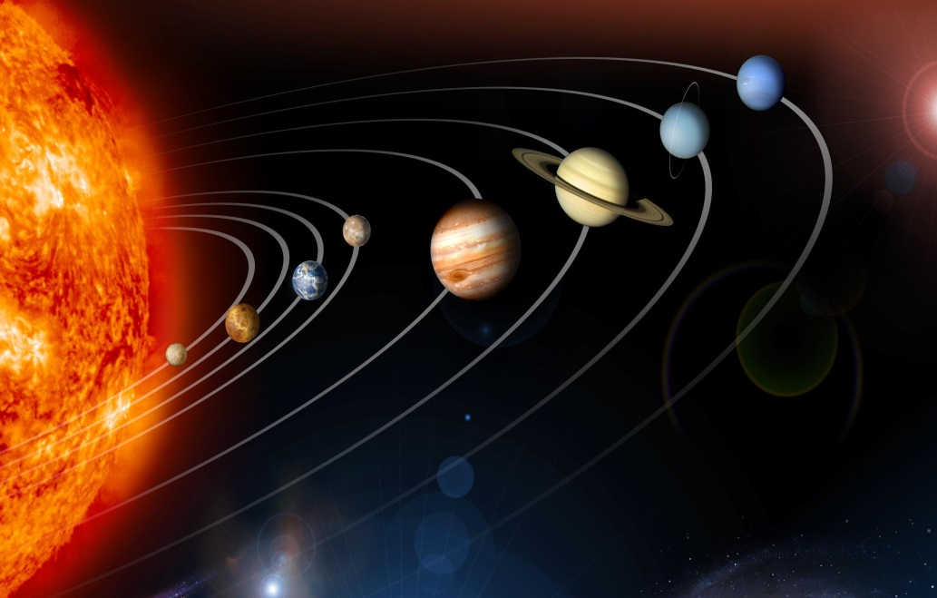

**Exercise 50.**

***A. Read the text. Ask 5 questions on it.***

**Why go to Mars?**

*Scientists* have already sent *satellites* to *explore* the surface of Mars, and *carried out experiments* to see if they can *discover* any signs of life. So far, they haven’t found any, but an *analysis* of rocks from Mars has *confirmed* that they were created by the presence of water and wind. In other words, life could have *existed* in the past.

***B. Match the words on the left with their definitions on the right.***

|  |  |
| --- | --- |
| 1. Scientist | a) travel around a place in order to learn about it. |
| 2.Satellite | b) do and complete a task |
| 3.Explore sth | c) a person who studies the physical world |
| 4.Carry out sth | d) sth is present in the real world |
| 5.Experiment | e) a piece of electronic equipment that is sent into space and move around |
| 6.Analysis | f) say or show that sth is true or define |
| 7.Confirm sth | g) a scientific test done in order to learn sth. |
| 8.Exist | h)a careful study of sth in order to explain it. |

***C. Learn about the words easily confused***

***1. Discover vs invent vs reveal***

If you discover something, you learn about or find something for the first time (n. discovery).

*e.g. They discovered a new star.*

If you invent something, you create something that didn’t exist before (n. invention).

*e.g. Who invented the telescope?*

If you reveal something, you uncover (show and display) which was hidden (n. reveal).

e.g. *X-rays reveal a fracture.*

***2. Scientist vs scholar vs researcher***

A person who is an expert in a science (physical or natural sciences) is called *a scientist.*

e.g. *Scientists warn of great earthquakes to come.*

A person who has profound knowledge of a particular subject in details is called *a scholar.*

*e.g. She is the most distinguished scholar in English literature.*

A person who studies a subject for a better understanding of facts is called *a researcher.* It is a generic term because both a scientist and a scholar are researchers.

*e.g. This study is being carried out by researchers of our university.*

***Work on your own and find out the difference between the following:***

* Space vs the space
* Rocket vs racket
* Explore vs investigate vs detect

***D. Choose the correct word:***

1. There was an experiment/exploration to test the levels of sugar in the blood.
2. These animals only *explore/exist* in South America – nowhere else.
3. They’re going to *explore/analyse* the area to see what they can find.
4. Scientists have *carried out/confirmed* experiments on animals.
5. Who *invented/discovered* the life-saving drug penicillin?
6. We’ve got the data, so now we need to *analyse/explore* it.
7. The *discovery/invention* of electric light bulb changed people’s lives.

***E. Complete the sentences using the correct form of the words on the right.***

1. Television was an incredible INVENT
2. There’s a report from a group of SCIENCE
3. The ... of penicillin was major importance. DISCOVER
4. We’re waiting for ... of the results. CONFIRM
5. There will be an .... of the findings in the laboratory. ANALYSE
6. The 60s and the 70s were an exciting period for space ... EXPLORE
7. Humans are always looking for the .... of new life forms. EXIST

***F. Complete the sentences.***

1. The police ... drugs inside his shoes.
2. At the moment there is no evidence that life ... on Mars.
3. They left camp and went to ... the countryside to see what they could find.
4. With the use of ... , TV can show news from anywhere in the world.
5. Scientists believe they will have to .... out further experiments.
6. I don’t know who first ... the camera. Do you?
7. We knew he was ill, but the doctors have now .... that it’s serious.

***G. Complete the questions and answers in the space quiz. The first letter of a word is given:***

Q: How long would a **r**... take to **r**... Mars?

A: It would take **a** ... 260 days.

Q: Is the **E...** the only **p...** in the solar **s...** where life **e...?**

A: Yes, most **s...** believe that to be true.

Q: Who **d...** the planet Venus?

A: Most people think it was the ancient Greeks.

Q: Who **i...** the first American rocket to go into **s...**?

A: Robert Goddard, in the early twentieth century.

Q: What are ‘Phobos’ and ‘Deimos’?

A: They are two small moons or **s...** which **c...** the planet Mars.

Q: How many stars are there in the **u...**?

A: Nobody knows for sure, but some say **r...** ten thousand billion billion!

***H. Check yourself by completing the definitions:***

*e.g. Sun= the star that shines during the day*

1. explore = ... round a place in order to learn about it
2. far-fetched = ... easy to believe
3. revolve around something = go round something in a ...
4. experiment = a scientific ... in order to learn or find out about something
5. scientist = a person who ... or teaches science
6. confirm = say or show that something is... or define
7. invent = create something that didn’t ... before

**Speaking corner**

**Exercise 51.**

***A. Answer the questions:***

1. Would you like to be an astronaut? Why or why not?
2. Would you rather go to the Moon or travel into space? Explain your choice.
3. What do you think are the biggest challenges of being an astronaut?
4. What small personal things would you take with you on a journey into space?
5. What would you say to an alien if you met one in space?
6. What does the acronym NASA mean?
7. What is the point of NASA? What’s its mission?
8. Why is NASA so interested in Mars?
9. How can you explain the term ‘solar system’?
10. What do you think is beyond our solar system?
11. How is the Earth unique in our solar system?
12. Would you like to go for a tour of the solar system? Where would you like to go?
13. Do you like reading news stories on the solar system?
14. What interesting fact do you know about our solar system?
15. Do you think humans will start destroying other parts of our solar system, just like we’re destroying Earth?
16. What are the laws of the universe?
17. Why are scientists so interested in finding out about the universe?
18. What three adjectives would you choose to describe the universe?

***B. Make your comments on these quotes:***

* Einstein said: «Two things are infinite: the universe and human stupidity; and I'm not sure about the universe». What does he mean? Do you agree?
* Stephen Hawking said: «We are just an advanced breed of monkeys on a minor planet of a very average star. But we can understand the Universe. That makes us something very special». Do you agree?
* Aldous Huxley said: «There is only one corner of the universe you can be certain of improving, and that's your own self». Do you agree?
* Dyer said: «Everything is perfect in the universe». Do you agree?

*Taken from: https://esldiscussions.com/*

**Writing Corner**

**Exercise 52.**

***Translate into English:***

1. Давайте поговоримо про космос і про те, що відбулося там уперше. Так, перший супутник було відправлено на орбіту в 1957 році. Перша керована людиною космічна місія відбулася в 1961 році. Людина вперше приземлилася на Місяці у 1969 році. Перший космічний човник було запущено у 1981 році. Уперше люди зайшли на Міжнародну Космічну Станцію у 2000 році. Першу чорну діру було відкрито у 2007 році.
2. Космічний літак – це транспортний засіб, який може літати та ковзати, як літак в атмосфері Землі, і маневрувати, як космічний корабель у космічному просторі.
3. Як стало відомо, люди, які відповідальні за дослідження космосу, мають менш благородні наміри, аніж я очікувала. Стало відомо, що багаті люди зможуть подорожувати в космос, коли захочуть. це ініціатива заробляння грошей не має нічого спільного з початковою метою дослідження космосу. Я проти такого виду експлуатації небесного світу. А що про це думаєте ви?
4. Як на вашу думку виглядає межа Всесвіту? Яку форму і колір має Всесвіт?
5. Чому ми знаємо про Всесвіт більше, ніж людський мозок?
6. Як ви думаєте, як виглядає край Всесвіту? Яку форму і колір має Всесвіт?
7. Чому ми знаємо про Всесвіт більше, ніж людський мозок?

**Questions for Discussion**

1. What are some animals that live in Ukraine?
2. Are there animal rights groups where you live?
3. Can you name some endangered species?
4. What do you think of hunting? Would you eat an animal that you killed yourself?
5. Do you think it is okay to free animals that have been in captivity all their lives? Why? Why not?
6. Do you think people should buy and wear fur coats?
7. What can people learn from animals?
8. Is it morally right to spend a lot of money on pets, rather than helping people in need?
9. Do you think it is a good pattern in general to judge people by their attitude towards animals? Explain why.
10. Do you think it is right to keep wild animals in a zoo?
11. If you could be an animal / plant what would you choose to be? Why?
12. If you don’t keep pets, please explain why?
13. Pets are considered to be a burden to most of the city dwellers. To what extent do you agree?
14. What is the difference between a pet and a wild animal?
15. Would you want to see aggressive dogs muzzled or banned?
16. What is safari? Would you go on a safari?
17. What do you think would animals say about humans if they could make a documentary movie about humans?

**The List of Self-study Topics:**

1. In the Rainforest.
2. Wild animals and their habitats.
3. On a Farm: domestic animals.
4. Farmer’s Work: producing crops and raising animals.
5. Are Zoos Ethical?
6. Why do People Keep Pets?
7. Flora of Ukraine.
8. In the Garden: activities and tools.
9. Geographical Features: sea and coast.
10. The World Ocean: Facts and Information.
11. Geographical Features: inland.
12. The Highest Mountains on Earth.
13. Volcano Facts.
14. The Most Spectacular Deserts in the World.
15. A Review on Most Beautiful Waterfalls in the World.
16. Amazing Caves around the World.
17. River System in Ukraine.
18. Natural Wonders of Ukraine.
19. Milky Way Galaxy.
20. Ukraine’s contribution to space exploration.

**The List of Projects:**

1. Wildlife in Africa. Going on a safari.
2. Wildlife in Australia.
3. Comparing Wildlife in Europe and North America.
4. The Sea Creatures: Cute and Scary.
5. Birds A-Z.
6. Endangered and Threatened Species and the Red Data Book.
7. The 10 Best Zoos in the World.
8. Best Botanical Gardens around the World.
9. The Most Stunning Nature Reserves in Ukraine.
10. Types of Pet Animals.
11. Animal Shelters: Ways to Help.
12. Farmer’s Tools and Equipment.
13. Famous Farm Songs, Nursery Rhymes and Riddles.
14. The Garden of my Dream.
15. Travelling to Mars: a myth or reality?

**References**

1. Ruth Gairns & Stuart Redman (2008). Oxford word Skills: Intermediate. Oxford University Press. 256 p.
2. Ruth Gairns & Stuart Redman (2013). Oxford word Skills: Advanced. Oxford University Press. 256 p.
3. Ruth Gairns & Stuart Redman (2020). Oxford Word Skills 2nd Edition Upper-Intermediate–Advanced (Ruth Gairns, Stuart Redman), Oxford University Press. 256 p.
4. Chris Gough (2000). English Vocabulary Organiser: 100 Topics for Self Study 1st Edition. Heinle ELT. 224 p.
5. Marta Rosinska &others (2016). Get 200. Exam preparation course for Ukraine. Book 2. Macmillan Publishers Limited. 176 p.
6. Gregory Manin (2018). Oxford Exam Trainer B1. Oxford University Press. 208 p.
7. Helen Weale (2020 ). Oxford Exam Trainer B2. Oxford University Press. 184 p.
8. Luke Prodromou (2016) Grammar and vocabulary for Cambridge First (2nd edition). Pearson Education Limited. 320 p.
9. E. Moutsou (2016). Use of English B2. For All Exams. Macmillan Publishers Limited. 186 p.
10. ESL Discussions (n.d.). Retrieved from https://esldiscussions.com/
11. Oxford Learner’s Dictionary (n.d.) Retrieved from https://www.oxfordlearnersdictionaries.com/definition/english/topic?q=topic